# Question 2.8

## Code

clc

clear all

r=3;

h=[1 5 12];

% part a

Volume=pi*r^2.*h

%part b

H=12;

b=[2 4 6];

Area=(H.*b)./2

% part c

volume_prisam=(6*H.*b)./2

## Output

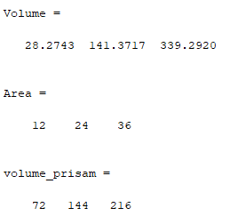

# Question 3.6

## Code

clc

clear all

v0=100;

g=9.81;

theta=[0:pi/100:2*pi];

range=(v0^2/g).*sin(2*theta);

format short e

table=[theta' range']

## Output

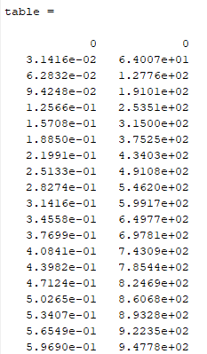

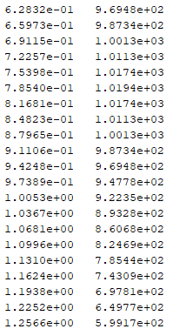

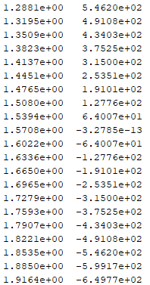

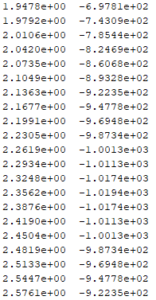

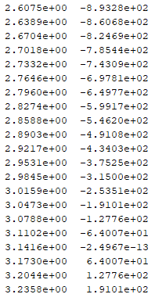

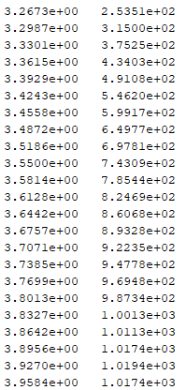

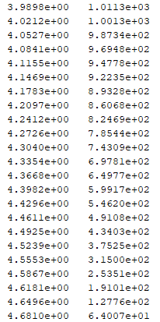

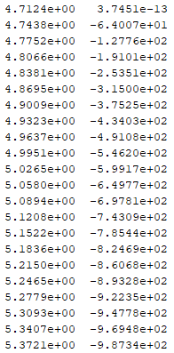

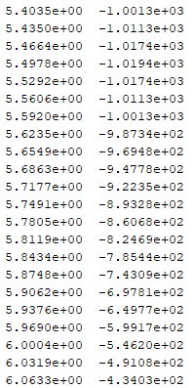

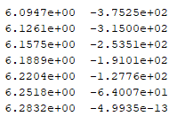

# Question 4.1

## Code

clc

clear all

a=[15 3 22; 3 8 5; 14 3 82];

b=[1;5;6];

c=[12 18 5 2];

d=a(:,3)

e=[b,d]

f=[b;d]

g=[a;c(1,1),c(1,2),c(1,3)]

h=[a(1,3) c(1,2) b(2,1)]

## Output

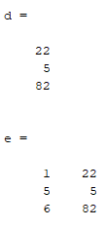

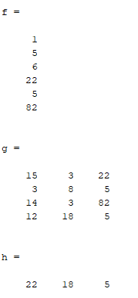

# Question 4.9

## Code

clc

clear all

Temp=[100:100:1000];

Pres=[100:100:1000];

R=0.2870;

[P,T]=meshgrid(Pres,Temp);

v=(R.*T)./P

## Output

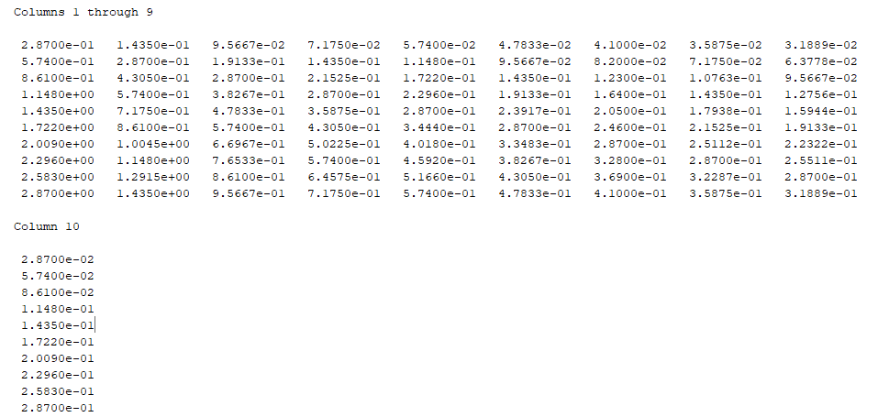

# Question 4.14

## Code

clc

clear all

% part a

magic_=magic(4)

m1=magic_(:,1);

m2=magic_(:,2);

m3=magic_(:,3);

m4=magic_(:,4);

new=[m1 m3 m2 m4]

% part b

c=sum(new)

r=sum(new')

d=sum(diag(new))

rd=sum(diag(fliplr(new)))

## Output

